Project: Creditworthiness

Complete each section. When you are ready, save your file as a PDF document and submit it here: <https://classroom.udacity.com/nanodegrees/nd008/parts/11a7bf4c-2b69-47f3-9aec-108ce847f855/project>

# Step 1: Business and Data Understanding

Provide an explanation of the key decisions that need to be made. (250 word limit)

## Key Decisions:

Answer these questions

* What decisions needs to be made?

As a loan officer at a young and small bank (been in operations for two years) we need to come up with an efficient solution to classify new customers on whether they can be approved for a loan or not. Due to a financial scandal that hit a competitive bank last week, suddenly we have an influx of new people applying for loans at our bank instead of the other bank in your city. All of a sudden, we have nearly 500 loan applications to process this week! Historically our team used to get 200 loan applications per week and approve them by hand. This will be a tremendous task with the sudden influx of such overwhelming number of applications. We need an efficient way to do that by developing a classification model. The model will predict the creditworthiness of the customers who have applied for the loan.

* What data is needed to inform those decisions?

We have the following information to work with:

1. Data on all past applications.

Credit Application Result, Account Balance, Duration of Credit Month, Payment Status of Previous Credit, Purpose, Credit Amount, Value Savings Stocks, Length of current employment, Instalment per cent, Most valuable available asset, Age years, Type of apartment, No of Credits at this Bank.

1. The list of customers that need to be processed in the next few days

Account Balance, Duration of Credit Month, Payment Status of Previous Credit, Purpose, Credit Amount, Value Savings Stocks, Length of current employment, Instalment per cent, Most valuable available asset, Age years, Type of apartment, No of Credits at this Bank

* What kind of model (Continuous, Binary, Non-Binary, Time-Series) do we need to use to help make these decisions?

As the answer to this problem is Binary (creditworthy / non- creditworthy), we need to build a model that best fit with it. In order to achieve it, I’ll compare the following binary classification models and choose the one that performs best:

* Logistic Regression.
* Decision Tree.
* Random Forest.
* Boosted Model

We will compare the accuracy of the above models and would select the best model for prediction.

# Step 2: Building the Training Set

*Build your training set given the data provided to you. The data has been cleaned up for you already so you shouldn’t* ***need to convert any data fields to the appropriate data types.***

*Here are some guidelines to help guide your data clean up:*

* For numerical data fields, are there any fields that highly-correlate with each other? The correlation should be at least .70 to be considered “high”.
* Are there any missing data for each of the data fields? Fields with a lot of missing data should be removed
* Are there only a few values in a subset of your data field? Does the data field look very uniform (there is only one value for the entire field?). This is called “low variability” and you should remove fields that have low variability. Refer to the "Tips" section to find examples of data fields with low-variability.
* Your clean data set should have 13 columns where the Average of **Age Years** should be 36 (rounded up)

***Note:*** *For the sake of consistency in the data cleanup process, impute data using the median of the entire data field instead of removing a few data points. (100 word limit)*

***Note:*** *For students using software other than Alteryx, please format each variable as:*

|  |  |
| --- | --- |
| **Variable** | **Data Type** |
| Credit-Application-Result | String |
| Account-Balance | String |
| Duration-of-Credit-Month | Double |
| Payment-Status-of-Previous-Credit | String |
| Purpose | String |
| Credit-Amount | Double |
| Value-Savings-Stocks | String |
| Length-of-current-employment | String |
| Instalment-per-cent | Double |
| Guarantors | String |
| Duration-in-Current-address | Double |
| Most-valuable-available-asset | Double |
| Age-years | Double |
| Concurrent-Credits | String |
| Type-of-apartment | Double |
| No-of-Credits-at-this-Bank | String |
| Occupation | Double |
| No-of-dependents | Double |
| Telephone | Double |
| Foreign-Worker | Double |

*To achieve consistent results reviewers expect.*

*Answer this question:*

* In your clean-up process, which fields did you remove or impute? Please justify why you removed or imputed these fields. Visualizations are encouraged.

I started with Data Exploration, exploring and visualizing the data distribution and identifying which fields could be removed because of its “Low Variability” and huge amount missing value.

The summary of the full data set with ‘na_count’ (count of missing value) is as follows,

|  |  |
| --- | --- |
| Variables | na_count |
| Credit-Application-Result | 0 |
| Account-Balance | 0 |
| Duration-of-Credit-Month | 0 |
| Payment-Status-of-Previous-Credit | 0 |
| Purpose | 0 |
| Credit-Amount | 0 |
| Value-Savings-Stocks | 0 |
| Length-of-current-employment | 0 |
| Instalment-per-cent | 0 |
| Guarantors | 0 |
| Duration-in-Current-address | 344 |
| Most-valuable-available-asset | 0 |
| Age-years | 12 |
| Concurrent-Credits | 0 |
| Type-of-apartment | 0 |
| No-of-Credits-at-this-Bank | 0 |
| Occupation | 0 |
| No-of-dependents | 0 |
| Telephone | 0 |
| Foreign-Worker | 0 |

So as per the above table, we can see ‘Duration-in-Current-address’ & ‘Age-years’ are two variables with missing values. ‘Duration-in-Current-address’ has around 68.8 % values missing. We can not accept this field in our model with such high number of missing values. Hence, we will drop this variable. ‘Age-years’ has only 2.4 % missing vales. Omitting the data associated with this small amount of missing value could be valuable. Hence, we would replace these missing values with their median value, 33.

Using the "average values" could insert a skewed graph in our model based on the age of the current clients, in this case we would be inputting an error/bias in our model and it could return a biased analysis, for example: if we train/teach our model that people with 50+ years are the most reliable/creditworthy, most of the new customers that have less than 50 years probably wouldn’t be accepted in our bank, but this concept of reliability was based in our current customers and this couldn’t be (and probably isn’t) an indisputable truth, especially when compared with a large amount of data.

When we’re using the median of age-years, we’re inputting the median value between the oldest and youngest, representing the age group that we attend in our bank. Even though this method input some errors in our dataset, at least our dataset isn’t biased, and these errors tend to be lower than the average method when applying our model with a large age group.

The box plot and the associated data is shown below.

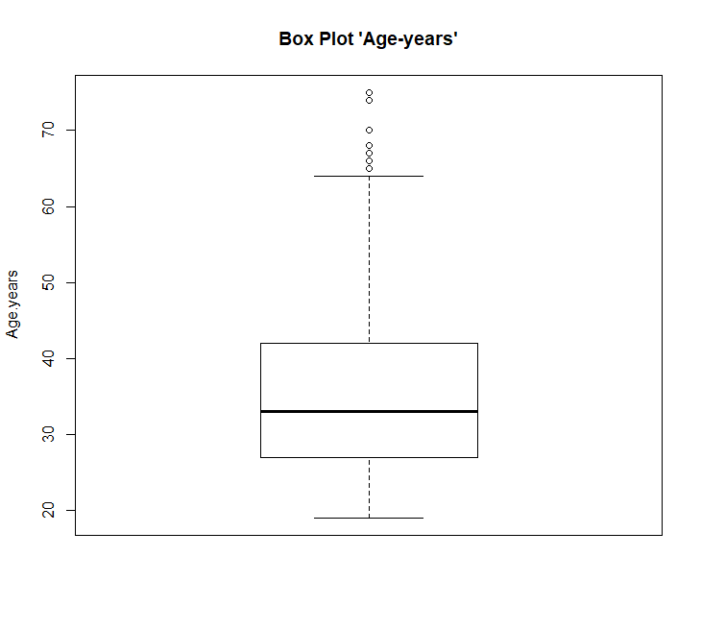

Min. 1st Qu. Median Mean 3rd Qu. Max. NA's

19.00 27.00 33.00 35.64 42.00 75.00 12

The statistical summary of the all the numeric variables are as follows,

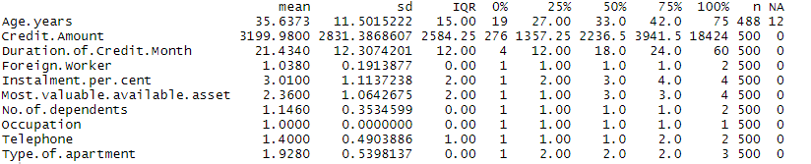

Some interesting results appear!! Let us visualize them.

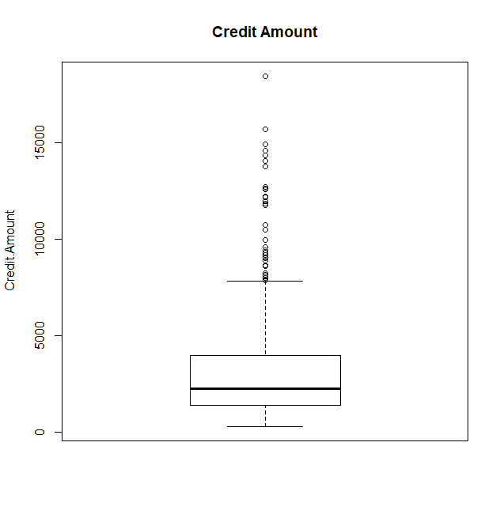 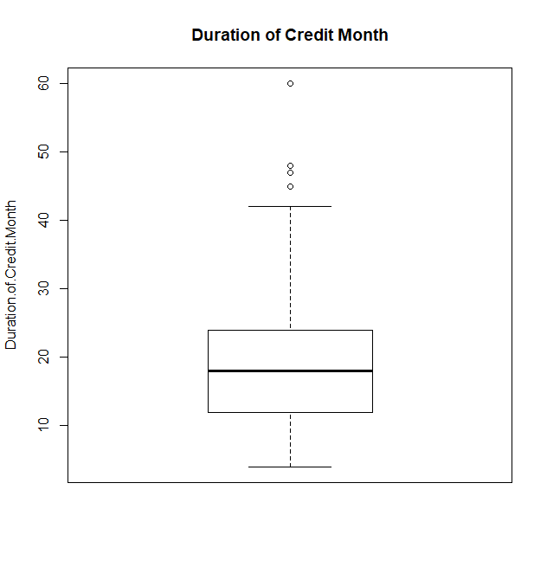

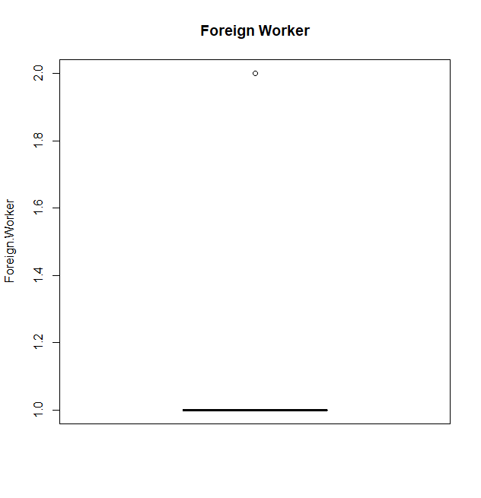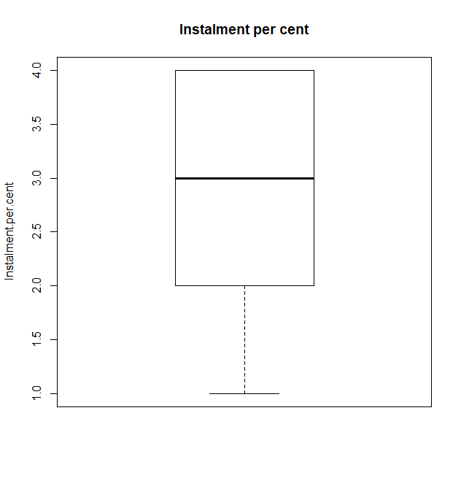

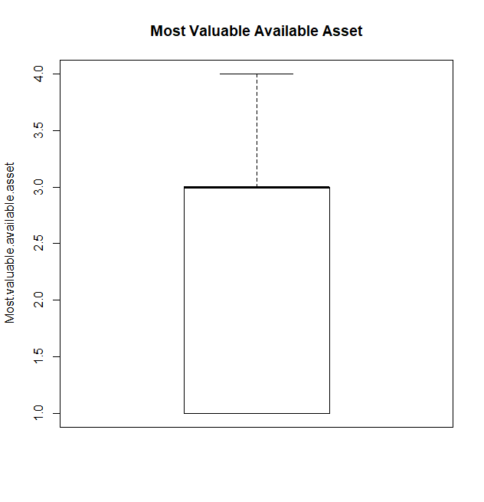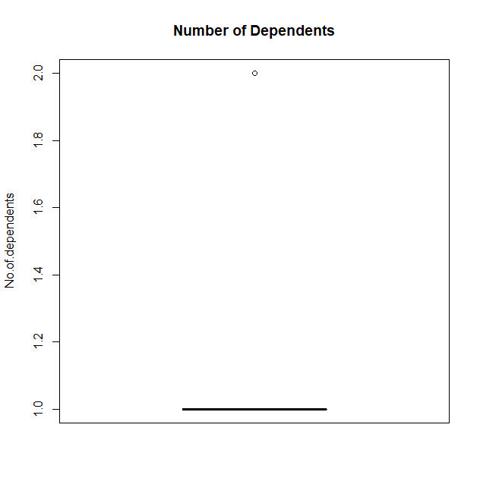 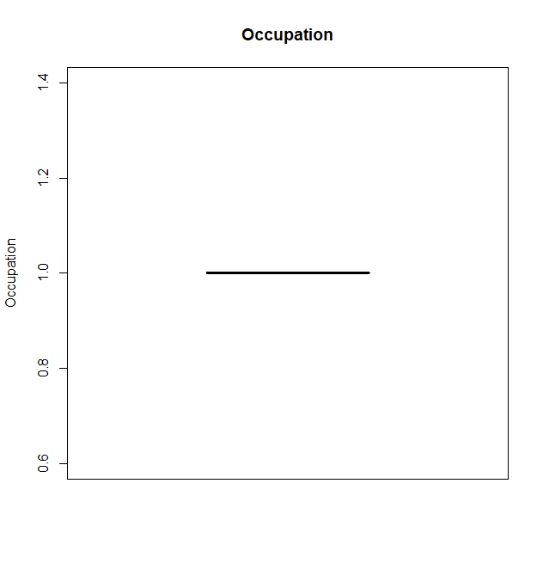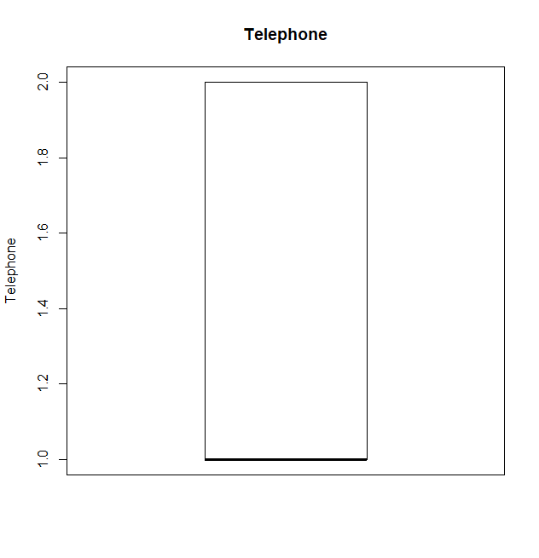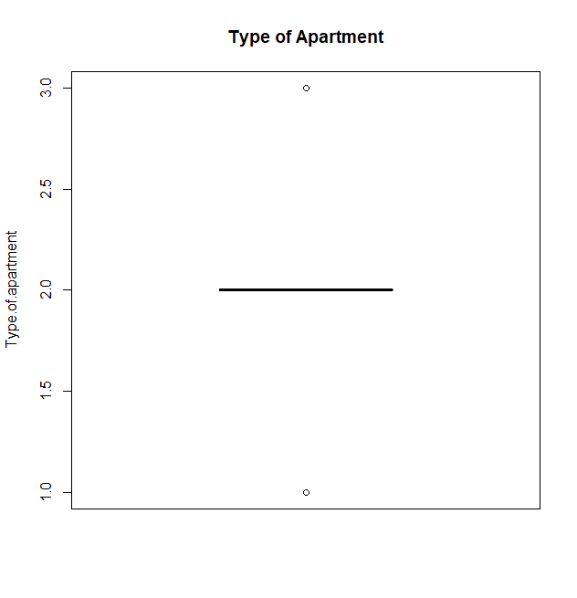

From the above boxplots, we can easily identify the “low variability” variables,

* Foreign Worker
* Number of dependents
* Occupation
* Type of apartment

We would remove them from our model.

Now let us look at the non-numeric variables in data set,

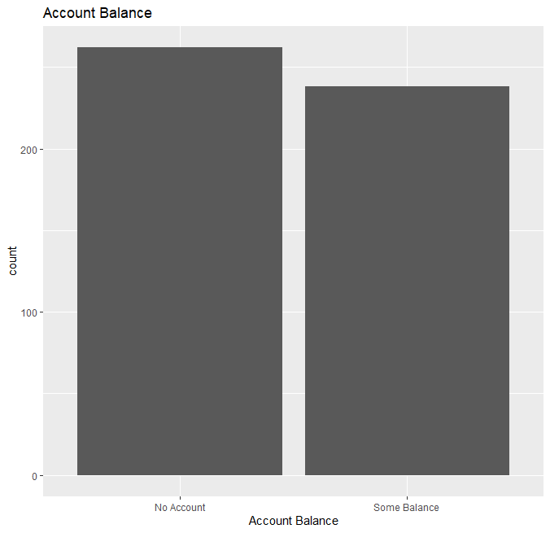 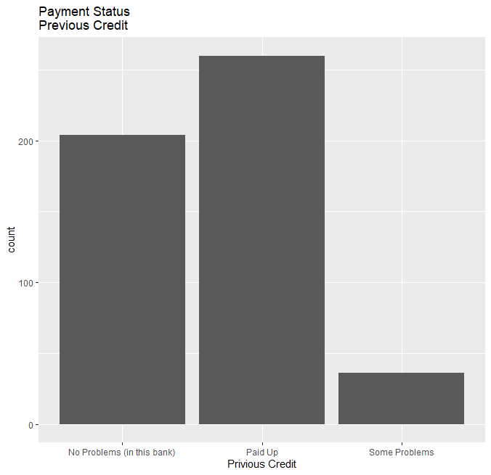

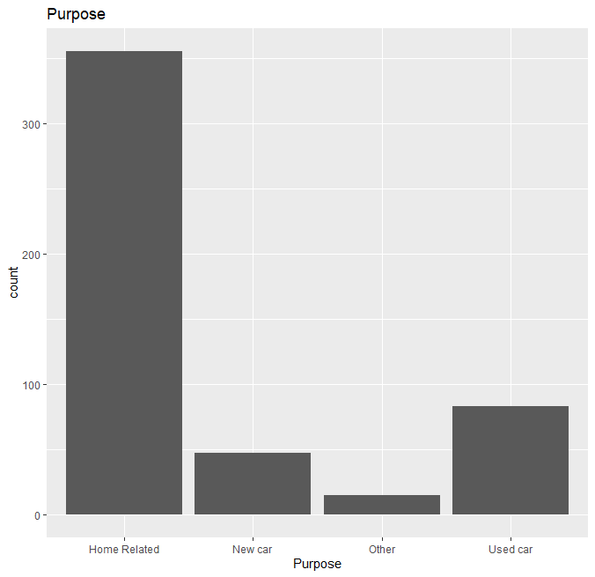 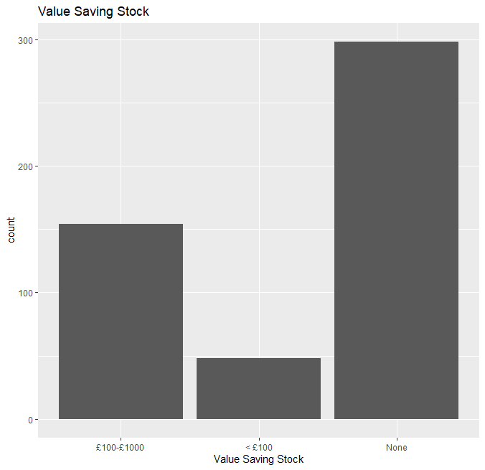

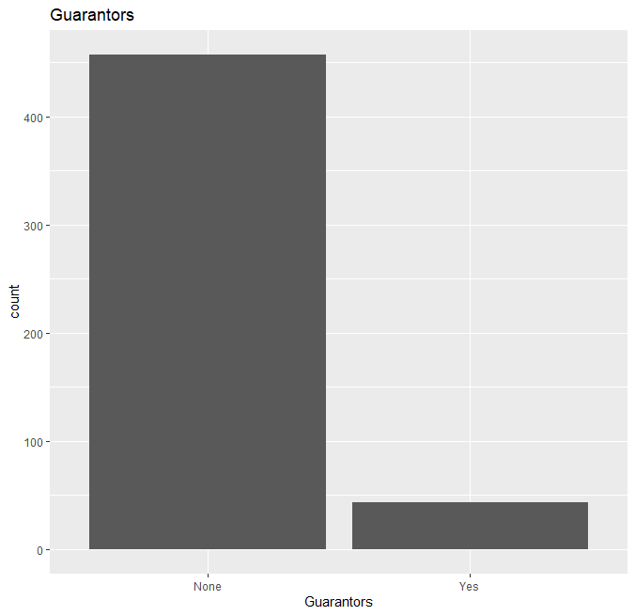 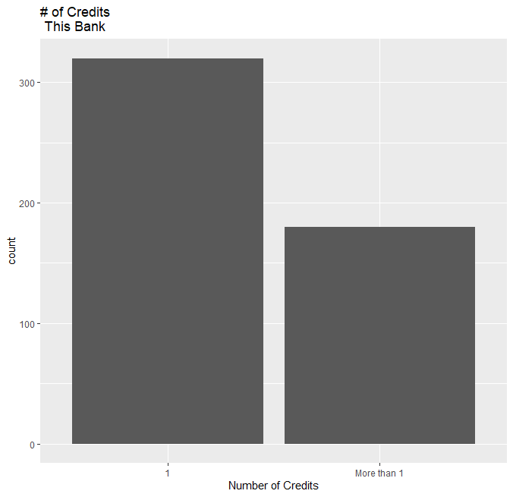

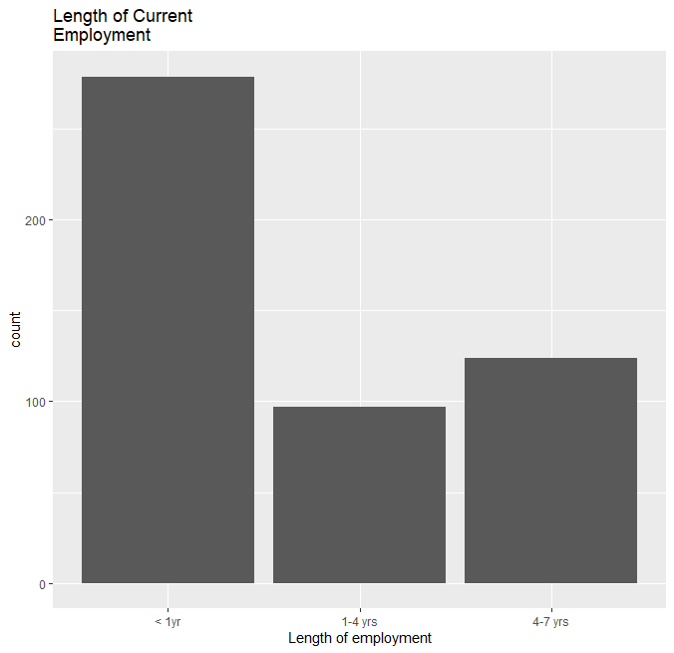 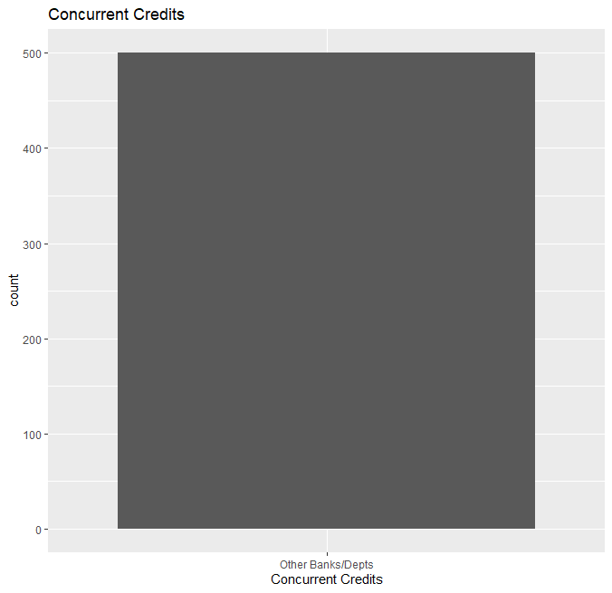

We can remove the variable ‘Concurrent Credit’ & ‘Guarantor’ due to low variability.

So the vriables in the final cleaned data set is as follows,

|  |  |
| --- | --- |
| Variable | Data Type |
| Credit-Application-Result | character |
| Account-Balance | character |
| Duration-of-Credit-Month | numeric |
| Payment-Status-of-Previous-Credit | character |
| Purpose | character |
| Credit-Amount | numeric |
| Value-Savings-Stocks | character |
| Length-of-current-employment | character |
| Instalment-per-cent | numeric |
| Most-valuable-available-asset | numeric |
| Age-years | numeric |
| No-of-Credits-at-this-Bank | character |
| Telephone | numeric |

Showing 1 to 13 of 13 entries, 1 total columns

# Step 3: Train your Classification Models

*First, create your Estimation and Validation samples where 70% of your dataset should go to Estimation and 30% of your entire dataset should be reserved for Validation. Set the Random Seed to 1.*

First task is to split the data set of 500 rows, into training set and the test set to validate the accuracy and acceptability of the model. So, we need a training set that will have 350 observations and a test set with 150 observations.

Randomly 350 observation were selected and the balanced one was selected for test set.

In order to test the uniformity of these two sets, the predicted variables percentage distribution was checked.

|  |  |  |
| --- | --- | --- |
| Set | Creditworthy (%) | Non-Creditworthy |
| Training Set | 68.5% | 31.5 % |
| Test Set | 78.6 % | 21.4 % |

So, we can assume that both sets are relatively unbiased.

*Create all of the following models: Logistic Regression, Decision Tree, Forest Model, Boosted Model*

*Answer these questions for* ***each model*** *you created:*

* Which predictor variables are significant or the most important? Please show the p-values or variable importance charts for all of your predictor variables.
* Validate your model against the Validation set. What was the overall percent accuracy? Show the confusion matrix. Are there any bias seen in the model’s predictions?

*You should have four sets of questions answered. (500 word limit)*

1. **Model Name: Decision Tree**

The first model that I have developed is a decision tree model.

The tree as per the training set are as follows,

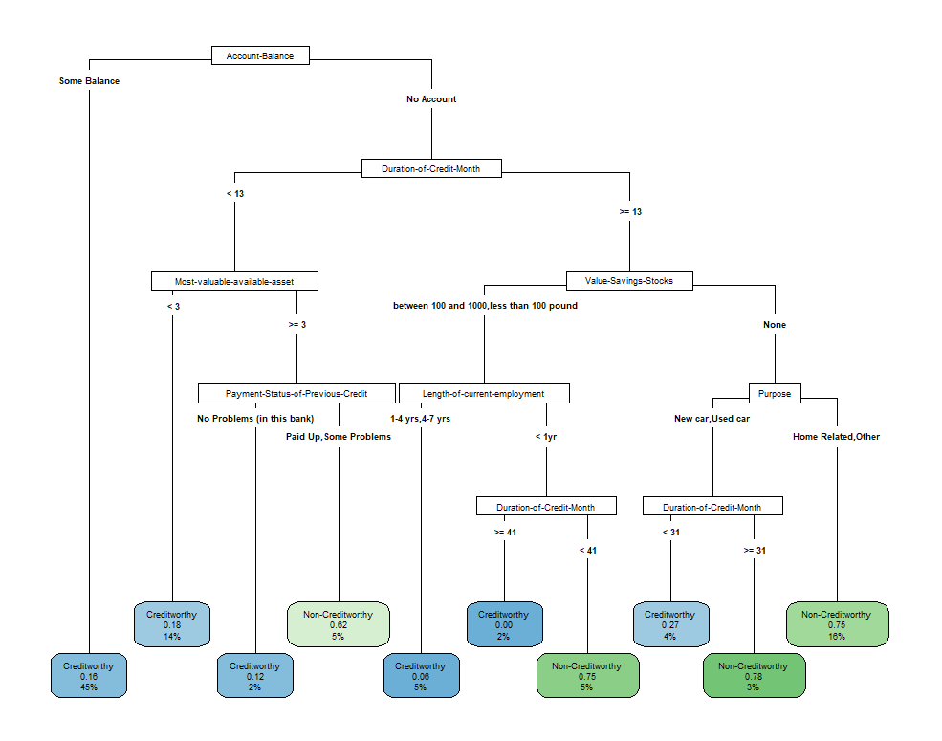

The variable importance table are mention below,

|  |  |
| --- | --- |
| Duration-of-Credit-Month | 23 |
| Account-Balance | 19 |
| Credit-Amount | 14 |
| Value-Savings-Stocks | 12 |
| Payment-Status-of-Previous-Credit | 7 |
| Length-of-current-employment | 7 |
| Purpose | 6 |
| Age-years | 5 |
| Most-valuable-available-asset | 4 |
| No-of-Credits-at-this-Bank | 3 |
| Instalment-per-cent | 1 |

Account Balance, Value Savings Stocks and Duration of Credit Month are the top 3 most important variables.

The model summary report is as follow,



Now we used the model to validate the test data,

We found that the model predicted 116 application as “Creditworthy” and 34 “Non-Creditworthy”.

And the confusion matrix is as follows,

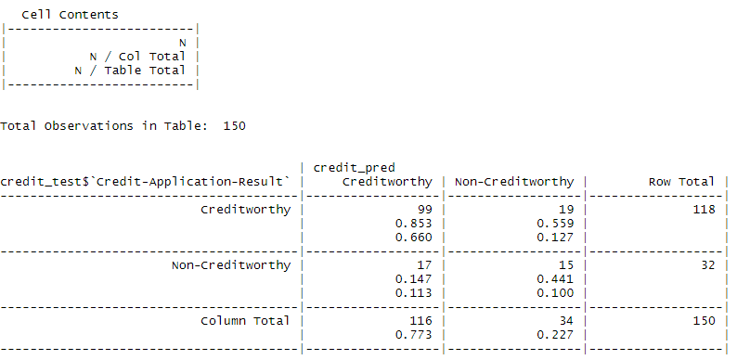

**So, model accuracy = 76 %.**

1. **Model Name: Logistic Regression**

The second model was developed was logistics regression model.

The full model was first developed and then a stepwise regression model was developed to find the best model.

The full logistic model report is as follows,

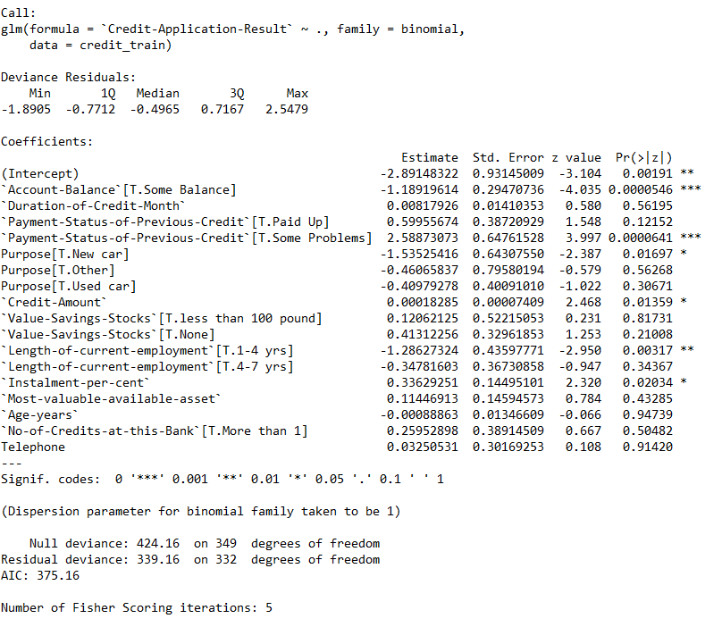

The stepwise regression model report is as follows,



The selected model based on lowest AIC value is as follows,

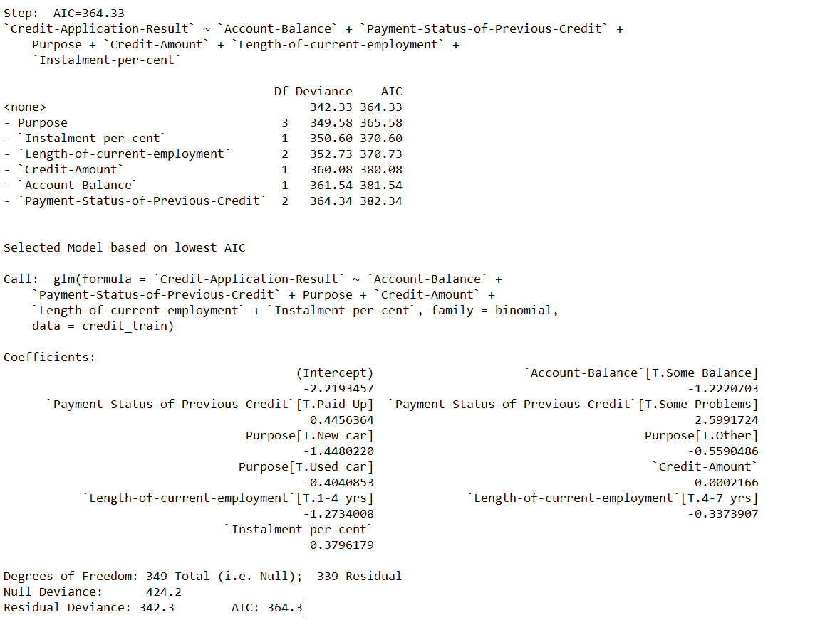

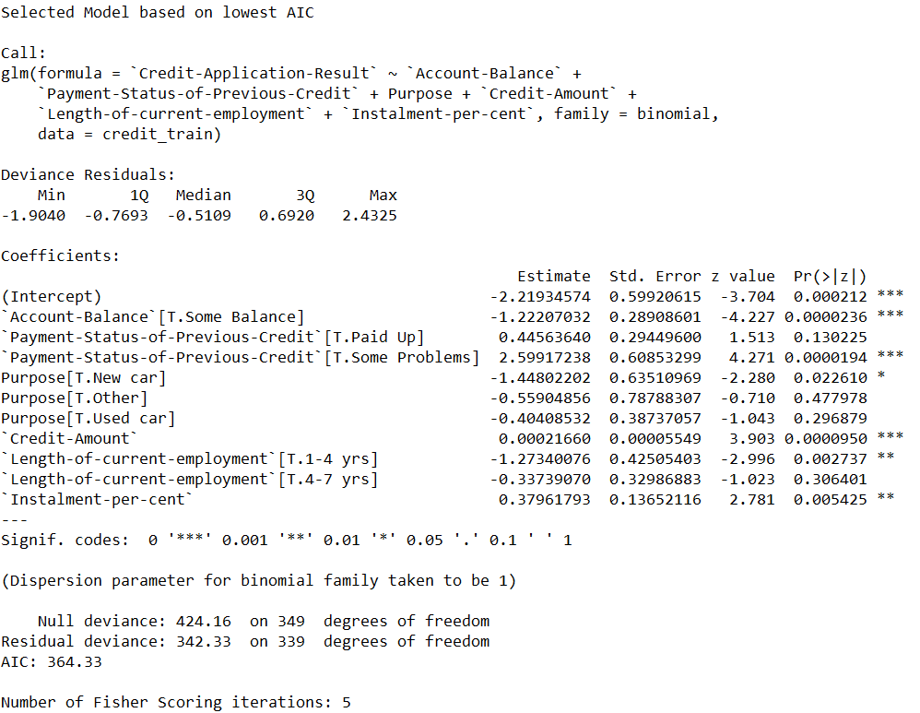

As per the logistics model, most significant variables with p-value of less than 0.05.are, Account balance, payment status of previous credit, Purpose, values saving stocks, length of current employment.

Now we used the model to validate the test data,

The confusion matrix is,

Actual Creditworthy Actual Non-Creditworthy

Predicted Creditworthy 97 14

Predicted Non-Creditworthy 20 19

ROC Curve,

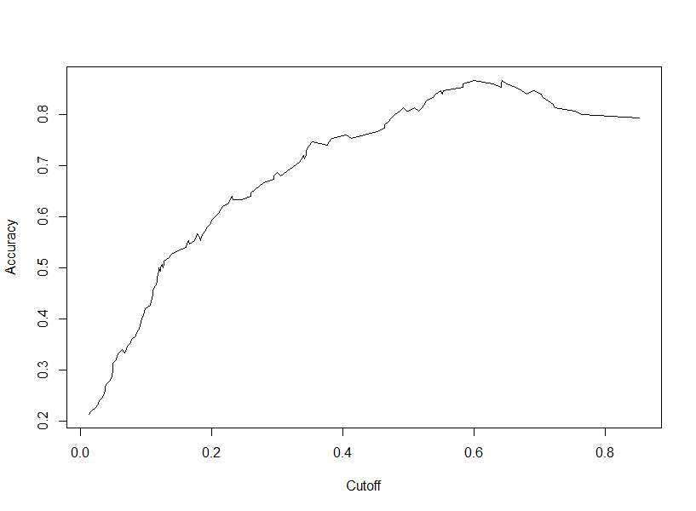

**Accuracy of the model is 77%**

1. **Random Forest Model**

The next model developed was random forest model.

The training data was used to train the forest model with 1500 trees and

Using Credit Application Result as the target variables, Credit Amount, Age Years and Duration of Credit Month are the 3 most important variables. The variable importance plot is as follows,

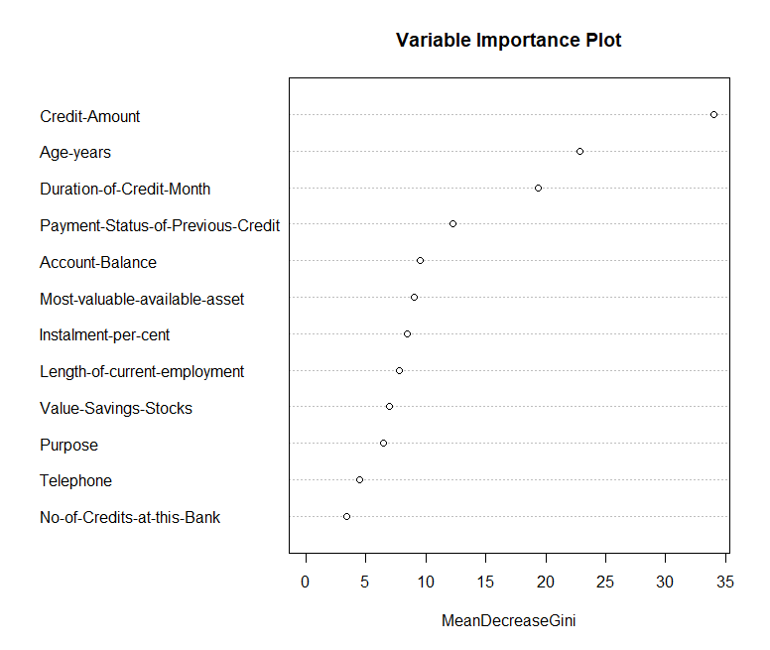

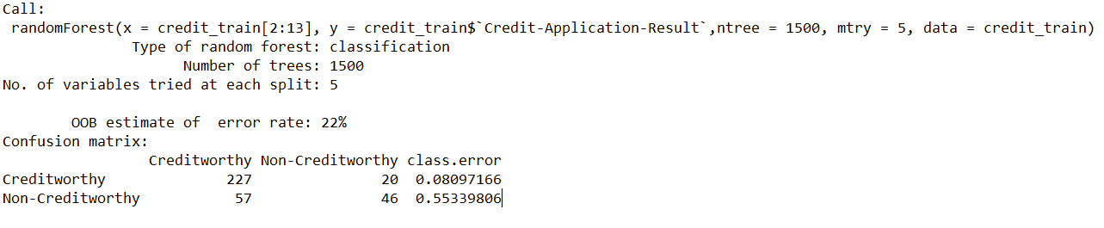

The MSE error rate for the training model is as follows,

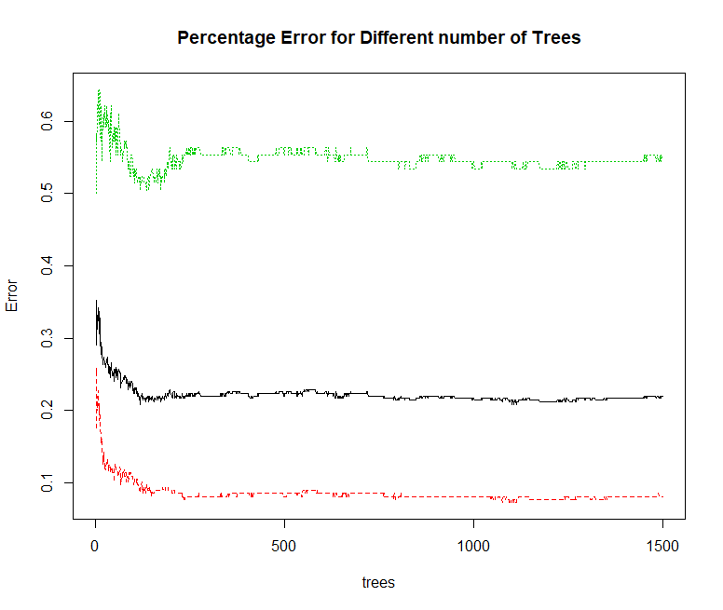

Once the Model is used to the test set, the predicted outcomes for the test set are,

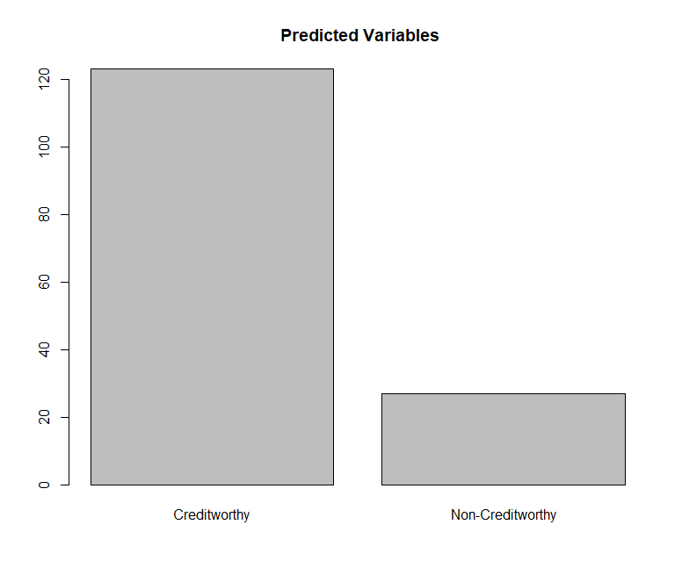

The confusion matrix for the test set as follows,

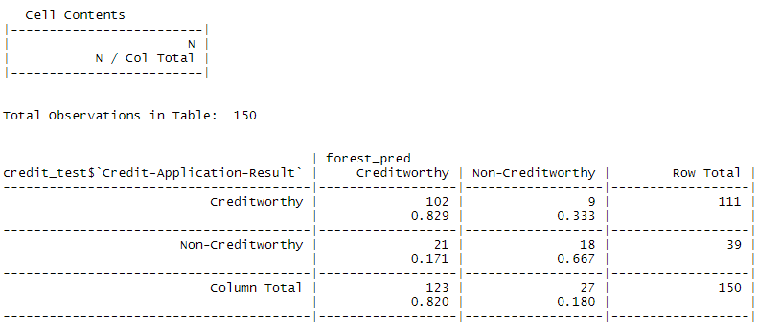

**The Accuracy of the model, 80%**

1. **Boosted Model**

The next model used was a boosted model.

The variable importance plot is shown below,

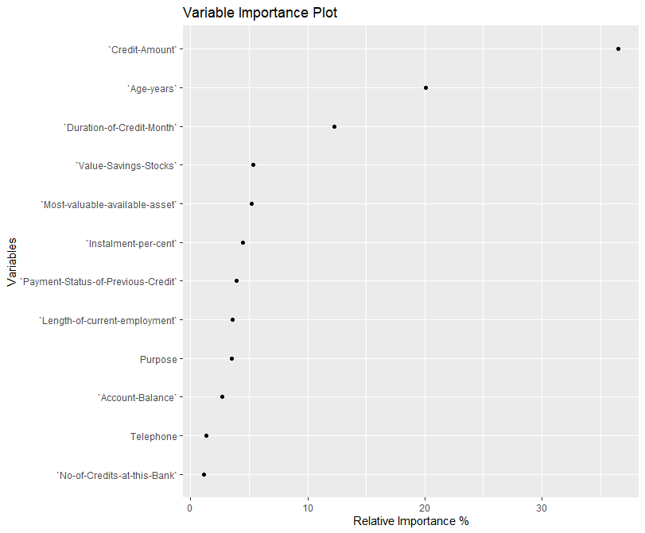

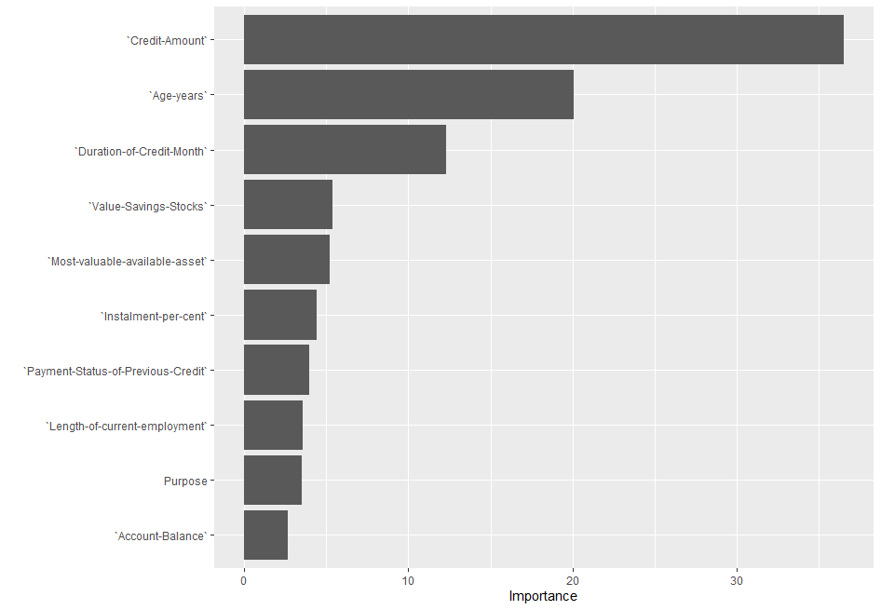

The error loss plot of the model,

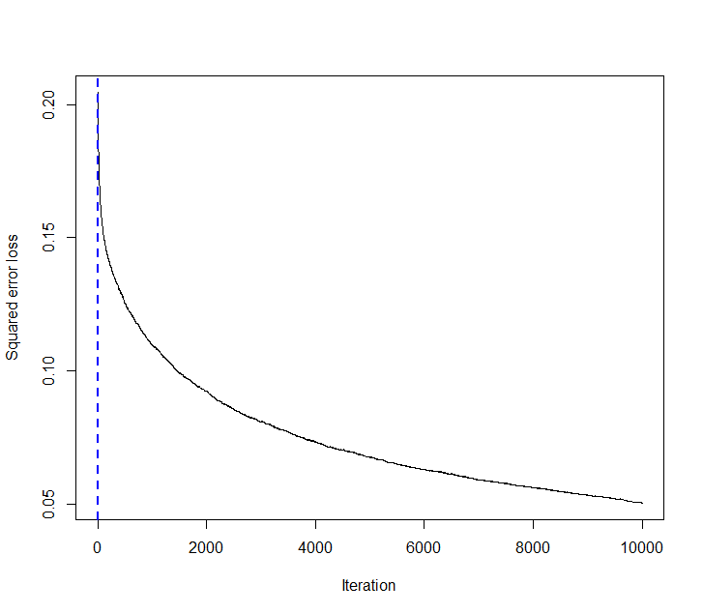

The confusion matrix is,

Actual Creditworthy Actual Non-Creditworthy

Predicted Creditworthy 100 27

Predicted Non-Creditworthy 5 18

Accuracy of the model 78.6 %

# Step 4: Writeup

The purpose of this report was to create a classification model to systematically evaluate the creditworthiness of new loan applicants. To do so, four standard models were compared in Alteryx, namely, Logistic Regression, Decision Tree, Forest Model and Boosted Model.

All the examined models demonstrated high classification accuracy (76% – 80%). However, they also demonstrated a high bias to correctly predicting applicants who were creditworthy. Indeed, for all models, the accuracy of correctly classifying application who were not creditworthy was worse than guessing at random (37 – 49%) while correctly classifying applications as creditworthy was high (86% -96%). This is likely due to high class imbalance observed in the dataset and future reports should look to oversampling/under sampling methods.

Out of all the above models, the Forest Model accuracy is highest. Hence this model was chosen. The Accuracy is the utmost important parameter for selection of the model.

Applying the model to the new dataset, customers-to-score.xls and taking any applicant that has a greater Creditworthy accuracy score than non-creditworthy to mean the applicant should be granted a loan, **the final count of individuals who are creditworthy are 408.**